WHITIREIA YOUTH STUDENTS SPORTS DAY
PROGRAMME Monday 7 September, 2015 Te Rauparaha Arena
9.20am | Classes arrive to the Arena
9.30 – 9.40am | Introductions & Sports Briefing [Oratoa]
9.40 – 11am | Sport 1 [6 rotations = 15mins per rotation]
11 – 11.05am | Briefing for Sports 2
11.05 – 12.30pm | Sports 2 [6 rotations = 15mins per rotation]
12.30 – 1pm | Lunch
1 – 1.05pm | Briefing for Sports 3
1.05 – 2.30pm | Sports 3 [6 rotations = 15 mins per rotation]
2.30 – 2.40pm | Results & Finish

WHITIREIA YOUTH STUDENTS SPORTS DAY
ORGANISATION PLAN Monday 7 September, 2015 Te Rauparaha Arena
8.30 – 9.20am | Set up of Arena [Sound set up, points table, Sports gear set up, Team tables/chairs] | Tiketi & Team  Arena Staff
9.20am | Classes arrive to the Arena | Classes [Allocated table & seating]
9.30 – 9.40am | Introductions & Sports Briefing [Oratoa]  [Oratoa and MC to do briefings and intro.] | Classes & MC  Oratoa
9.40 – 11am | Sport 1 [6 rotations = 15mins per rotation] | Classes & Oratoa
11 – 11.10am | Briefing for Sports 2/Break [Change in set up] | Arena Staff & Oratoa
11.10 – 12.30pm | Sports 2 [6 rotations = 15mins per rotation]  [Oratoa and MC to do briefing] | Classes and MC  Oratoa
12.30 – 1pm | Lunch [Change in set up] | All classes to eat outside [Arena staff]
1 – 1.05pm | Briefing for Sports 3 | Oratoa & MC
1.05 – 2.30pm | Sports 3 [6 rotations = 15 mins per rotation]  [Oratoa and MC to do briefing] | Classes and MC  Oratoa
2.30 – 2.40pm | Results & Finish [Pack down] | All classes, Arena Staff

WHITIREIA YOUTH STUDENTS SPORTS DAY
CLASS PREPARATIONS Monday 7 September, 2015 Te Rauparaha Arena
STUDENT REMINDERS
Student Lunch & Drinks | Students to bring their own lunch. Students reminded ALL FOOD to be eaten outside of the Gym area.
Water Bottles/Drinks | Water bottles only allowed in the Gym. Each student to bring their own.
Shoes & Sports Gear | Encourage students to wear comfortable clothes for Sports.  Students Reminded to wear Sports shoes or Sandshoes only
CLASS REMINDERS
Class Banner | Classes are encouraged to produce a banner or flag for their class. Feel free to bring this and show off on the day
Class Colours/Uniform | OPTIONAL If possible, invite the students to come dressed in their TEAM COLOURS. No need to buy new shirts etc.
FIRST AID KIT | In the event of a minor accident, we will supply a First Aid Kit for staff to access on the day.
EMERGENCY | In anticipation of an emergency, we encourage all tutors to carry their cell phones and a list of student emergency contacts. At the start, we will outline Emergency Procedures.

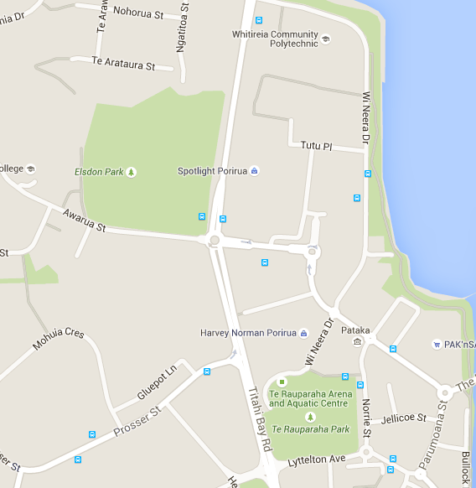
Arena
Trades Campus
Main Campus
WHITIREIA YOUTH STUDENTS SPORTS DAY
POTENTIAL RISKS & CONSIDERATIONS Monday 7 September, 2015 Te Rauparaha Arena
Event | Whitireia Youth Students Sports Day  Monday 7 September, 2015 9.30 – 3pm  Te Rauparaha Arena
Location | Refer to the location map for directions
Tutor Supervision | Tutors responsible for directing and supervising their classes or teams. This includes when travelling to and from the venue.
Emergency Contacts | Tutors encouraged to bring a list of their students emergency contacts in the event of an emergency
First Aid Kit | A First Aid Kit will be provided for students and tutors to utilise on the day
First Aid Room | Venue has a First Aid room that can be accessed if required
POTENTIAL RISKS OR INCIDENCES
During the Sports activities, a student is injured during the event |  | Minor Injury  Tutor and organising staff to access First Aid Kit to treat minor injuries [cuts, grazes]. Records incident.  Severe Injury  In the event of a more severe incident, the appropriate emergency service will be contacted. Venue has a First Aid Room that can be accessed if required. Tutor will refer to Emergency contact list to inform of incident, as well as contact relevant Faculty personnel [Dean, Programme Manager]. Incident to be recorded.
Venue has an emergency incident [Earthquake, Fire etc] |  | Introductions  As part of Introductions, the venue Health and Safety Procedures will be outlined for staff and students present.  Venue Health and Safety Procedures  Each classroom tutor and the event organisers will follow the venue Health and Safety Procedures for emergencies.
Incident or emergency involving a minor |  | Parent or Caregiver Consent  Tutors are responsible and encouraged to inform guardian and/or caregivers especially for students under 18yrs to either consent or be informed of the event. In the event of an incident, the caregiver or guardian is informed.
Incidences while travelling to and from the venue [roads, cars] |  | Each tutor is responsible for directing and supervising their classes. Please refer to the location map for safest route to the venue.

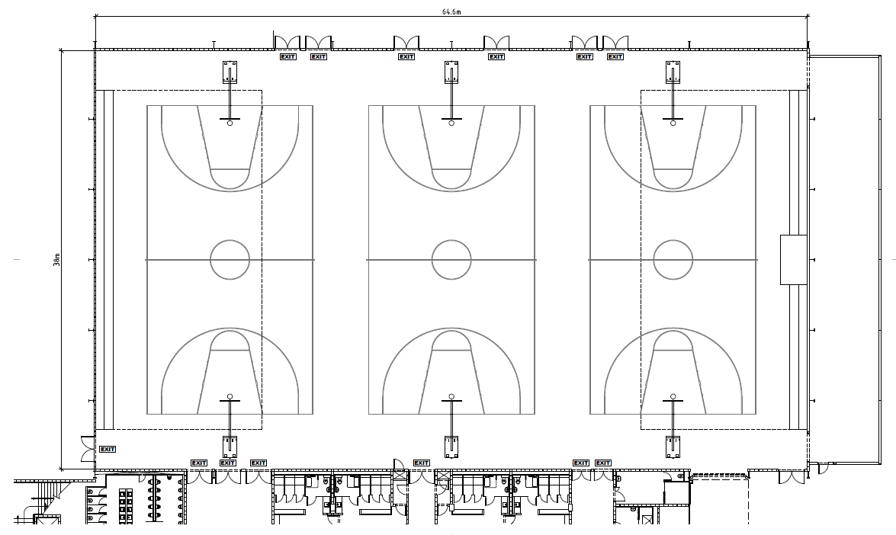
Entrance

