### New Zealand Sign Language Week

Kia ora tātou

Aotearoa/New Zealand has three official languages and next week especially celebrates one of them.

**New Zealand Sign Language**

You can access **resources** on <http://nzslweek.org.nz/>  and attached is a good chart to display.

Have a look at **Moodle** each day for a brief signed message from Su.

You can also access this **online signing course** during next week:

**We are inviting New Zealanders to Learn 25 Signs and go into a draw to win spot prizes**

**The FREE Online Taster Class will be live during NZSL Week - watch this space**

Remember: everyone who participates in a NZSL Taster Class (either live or on this site) can then complete a short quiz to go into the draw to win spot prizes.

<http://nzslweek.org.nz/>

Some good places to look further….

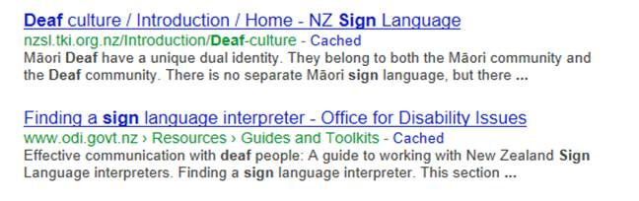

And more….

Remember, web resources are generally based on American Sign Language and NZSL is unique to Aotearoa.

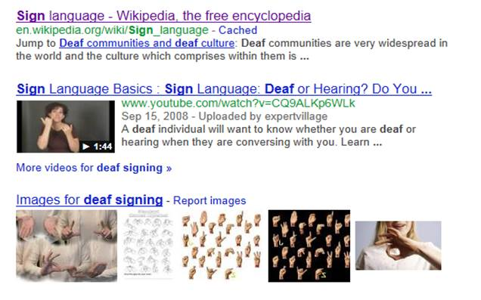

Enjoy your week!



|  |  |
| --- | --- |
| **Ken Munro** |  |
| **Group Leader**  **Te Pokapū Hiranga / Student Support Services** |