Notification of change coming for students
What is changing?  The change is to the existing Intranet page that opens:  - when you click on the Internet Explorer icon  - on entry to some older Whitireia computers | 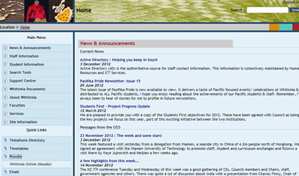

What will you see instead?
You will open instead to the front page of Whitireia Online (Moodle).

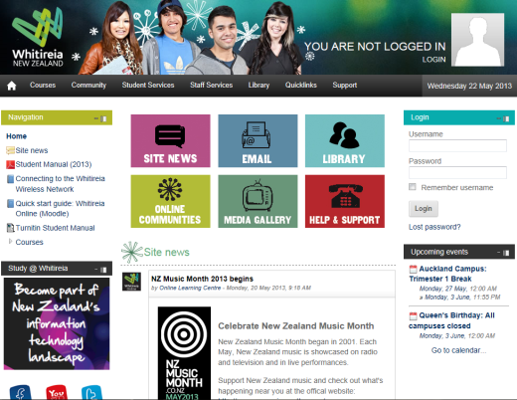

From there you can choose to:
- log in to Moodle, or
- type a webpage address into the browser search window to access an Internet page

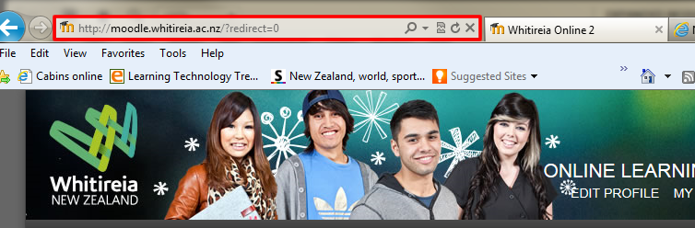

- use a new tab and a Favourites link to access an Internet page

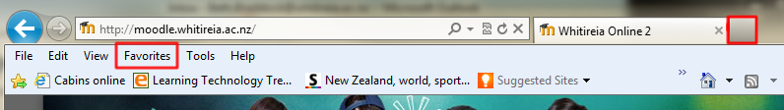

When will it change?
This change will occur in early June – we will inform you of the actual date closer to the time.

Other changes
A Whitireia New Zealand link has been added to the Whitireia Online Moodle Quicklinks drop menu.

You might notice other small changes occurring on the Moodle front pages as we adjust them to suit both students’ and the institution’s requirements.

